Hospital Information System with Mobile Technology

Christopher Lloyd Maquinto1, Jasmine Hazel Ng2, Juan Paolo Sarmiento3Lawrence Jello Shio4

and Ms. Lissa Andrea K. Magpantay1,*

*De La Salle University, IT Department*

*\* lissa.magpantay@delasalle.ph*

**Abstract:** As stated in Sections 11-13 of the 1987 Philippine Constitution, all Filipinos have a right to avail of quality healthcare at an affordable cost; moreover the state is responsible for the improvement of health care services. However, despite the efforts of both the government and the private sector, healthcare in the Philippines seems to be stagnant and improvement is slow. Moreover provincial hospitals experience much more tedious work given that they are located far away from the metro, meaning they may not have the latest technologies that can aid them in their day to day operations. Processes that concern health must be done fast and effective regardless of location, so that it might not jeopardize a person’s life.

This paper presents the development of a Hospital Information System with Mobile Technology for San Pablo Medical Center. The system covers the entire process of patient care: from admission to discharge.

Based on observations and interviews made, the researchers found out that the main problem being encountered in these types of hospitals was that they are having difficulty in managing patient health and requirements.

The main objective of this study is to effectively manage the patient’s requirements while inside the hospital and to provide a centralized access of information across all departments concerned with the patient’s health. The methodology used was Rapid Application Development (RAD); tools and technologies used were eclipse, JQuery, Android ADT, Google charts and calendar API, Bootstrap. A user acceptance test was conducted among the users and the results were satisfactory. The researchers conclude that the proposed system would aid hospitals in managing patient health and requirements and can serve as a business model for both private and public health institutions.

**Key Words:** Hospital Information System; Mobile Technology, Patient Care

1. INTRODUCTION

As stated in Sections 11-13 of the 1987 Philippine Constitution, all Filipinos have a right to avail of quality healthcare at an affordable cost; moreover the state is responsible for the improvement of health care services responsive to that of the needs of the Filipino people. However, despite the efforts of both the government and the private sector, healthcare in the Philippines seems to be stagnant and improvement is slow. According to the Universal Healthcare Study Group organized by UP Manila as well as the Department of Health (2014), within the country there is a big difference between the qualities of healthcare in the different sectors of society. This results to poor and unequal access to health services that all Filipinos deserve. One identified cause of this is that Information Systems are not being utilized to their fullest potential and usefulness. Moreover, the health and hospital information systems in the Philippines are too simplistic – the data are just gathered and recorded, and not utilized for their usefulness to the health care system.

Hospitals are an integral part of today’s society, they are institutions that are composed of different medical and professional staff, they are the ones that treat diseases and help improve the health of the mass public. Hospitals are very important nowadays because without it, people have no means of consulting regarding their health or help save their lives if in dire need. Hospitals are the ones responsible for handling patient healthcare of those who are coming in and out of their institution across their respective communities. Provincial hospitals experience much more tedious work given that they are located far away from the metro, meaning that they may not have the latest technologies that can aid them in their day to day operations.

ICT and information systems play a big role in streamlining and reengineering the processes in hospitals. Specifically, a hospital information system can allow patients to get fast and effective healthcare. Delays in patient admission can be minimized and patient records and test results can be updated immediately so that it can be easily viewed by the doctor. Adding a mobile application along with the HIS could definitely help allocate more time for patient care for it can allow the doctors and nurses to immediately view and update the current status of the patient. The doctor could recommend possible medications or diagnosis to the patient even though he/she is not in the hospital. Managing hospital operations efficiently through technology leads to satisfied stakeholders and makes the business viable in terms of cost reduction and streamlined processes.

Mobile integrated hospital information system is a system that uses a mobile phone-based software application to allow health workers to capture, store, process, transmit, and access patient records. Its primary goal is to lower costs and increase efficiency by eliminating redundancy and reducing the amount of time devoted to data input (Center for Health Market Innovations, 2014). Mobile access to existing clinical information systems through wireless networks is expected to improve the quality and safety of patient care, avoid errors, increase cost-effectiveness, and increase physician productivity and responsiveness. The system will make it simpler and faster to retrieve patient information, leaving more time to care for patients. The Integrated Hospital Information System Mobile (IHIS Mobile) solution will make this comprehensive medical information available on handheld devices and smart phones, even when doctors are away from the hospital. The system will offer physicians mobile wireless access not only to patient records, including X-ray and CT images, but also to real-time data from ICU monitors, bedside charts, and even live video feeds. (AUTM, 2009)

According to Shuaib (2011), mobile technologies are the technologies platforms that are developed for and used on mobile devices. In essence you can develop mobile technology on mobile technology on a computer or mobile device to create another mobile technology. The use of mobile technologies, especially in smartphones, is the increasing trend in the current generation since it is famous for its mobility or being capable of being moved readily from place to place without any hassle. Moreover, there can be a lot of applications or other programs in the mobile technology that can be accessed by the user anywhere and anytime thus being genuinely effective in terms of using in business.

The objective of the study is to develop a Hospital Information System with Mobile Technology for San Pablo Medical Center. This solution would utilize mobile technology for nurse and doctor usage, which would help them monitor the status of each patient and update conditions easily. The scope of the project will cover the admission of patient until the patient is discharged.

.

1. METHODOLOGY

The methodology used in this study is the Rapid Application Methodology (Figure 1) (casemaker.com, 2007). During requirements planning, the group was able to conduct interviews (face-to-face and email) to identify the problems and get the necessary forms through the support of its primary sponsor, Dr. Eala, the owner and managing director.

The researchers used Java, JavaScript, bootstrap, MySQL and Android language for the development of both the system and the mobile application during construction phase. There was weekly consultation with the adviser for the development of the modules. During the final stage (cutover), system testing was conducted as well as the user acceptance testing with the nurses and doctors. Results are discussed in section 3 below. There was a system walkthrough with the users and manuals were developed to help the users.



Figure 1: Rapid Application Development (RAD)

1. RESULTS AND DISCUSSION

Based on the data gathered and interview conducted by the proponents, San Pablo Medical Center main problem is the difficulty in managing patient health and health requirements. The proposed solution has six modules plus the mobile application. Refer to Figure 2 for the conceptual framework showing the sub-problems and modules.

In terms of its features and functionalities, most of the users were happy with the system, especially the doctors. All of the users agreed that the system’s process flow can be matched towards what really happens in the real world and they agree that this can hasten the process flow and ease up the load work but it would require retooling of the doctors in terms of technology use in order to optimize the system. Most of the users would want the system to be implemented in the hospital because it would increase the productivity of the

staff from different departments, doctors can easily access the lab results and would also enable them to communicate with one another and not having the trouble of going to the department themselves just to clarify or request a test. For example, the doctor can just log into the system and view the lab results of a patient. Refer to Figure 3 for the screen shot. They also find that the reports generation capability of the system is a good feature because they would easily know where to adjust with their service and allows them to be alerted to the trends of the peak season for a certain virus. In terms of ease of use or navigating the system, the responses range from Moderate to Very Easy to Use. This is probably because of the limited period of time to conduct the User Acceptance Testing.

The development cost is 1,052,321 only because the software cost is 0 since an open source was used. Installation cost is estimated at 266,500.00. Annual benefits are computed at 1,861,745.00 thus a payback period of 9 months with an return on investment (ROI) of 41%. San Pablo Medical Center has the necessary IT infrastructure already if the system is to be deployed.

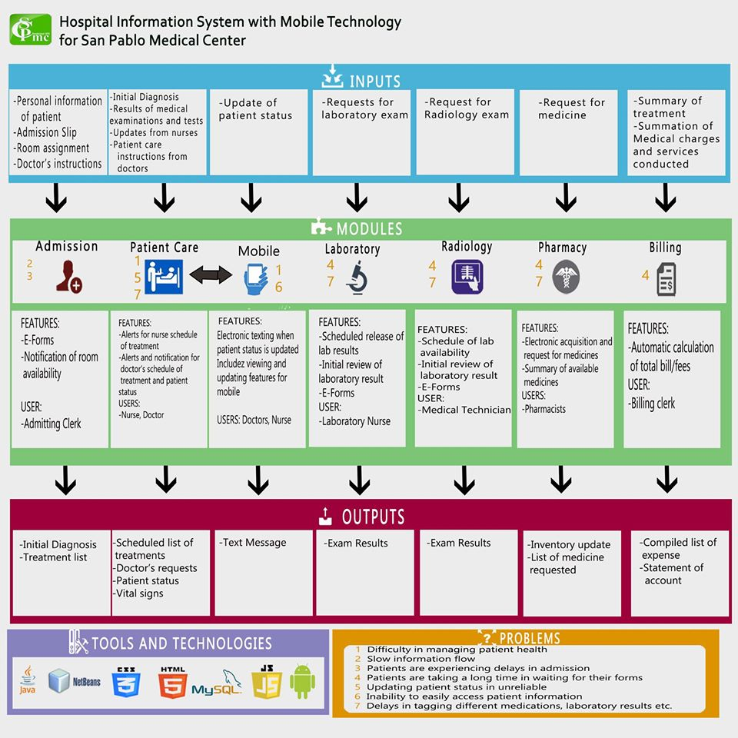Figure 2: Conceptual Framework

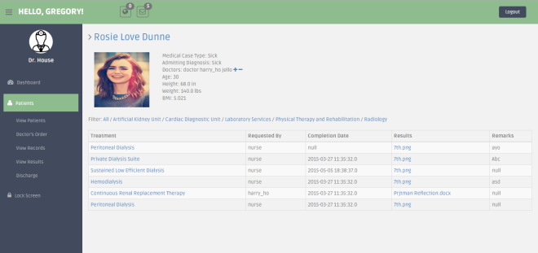

Figure 3: Doctor’s Page-View Patient’s Lab Results

1. CONCLUSIONS

The proposed Hospital Information System with Mobile Technology would greatly benefit the client hospital. With the use of the system necessary people concerning the patient’s health are properly informed regarding the condition of the patient. Managing the patient’s health requirements is made easier and faster and patients with high severity cases can be prioritized. During the hospital visits that the group conducted, they have observed that each department has computer units that are being used by the hospital staff and personnel. The proposed system can be installed in these already available computer units, provided that these computers can handle and store large amounts of information without slowing or crashing.

There is a need to set-up a network across the hospital. Also since the mobile application requires internet connection, mobile phones that will use the application must be connected to an internet provider. Although the hospital is found in a province, acquiring these connections and networks is not much of a hassle to the hospital for they are located in the town proper of the area, wherein internet service providers are available, also they are easily accessible for the location of the hospital is near the main road.

Not only is the system feasible for the hospital, it can increase their value by prioritizing on the patient’s health, which is what every hospital should aim for.

The proposed system may also benefit public hospitals so there is a need to conduct a study if the private hospital processes are similar to public hospitals and determine the best practices in order to come up with a generic public hospital information system.

1. ACKNOWLEDGEMENTS

The research proponents extend their deepest gratitude to the San Pablo Medical Center administration especially the owner and hospital director Dr. Gabriel Eala, the IT Department Head Mr. Adrian Ognaya, the nurses and doctors for allowing them to complete this project.

1. REFERENCES

Center for Health Market Innovations. (2006, January 1). Integrated Healthcare Information Service Through Mobile Telephony (IHISM). Retrieved November 11, 2014, from http://healthmarketinnovations.org/program/integrated-healthcare-information-service-through-mobile-telephony-ihism Integrated Healthcare Information Service Through Mobile Telephony (IHISM). Retrieved November 11, 2014, from <http://healthmarketinnovations.org/program/integrated-healthcare-information-service-through-mobile-telephony-ihism>

Definition: Mobile Technology. Retrieved November 11, 2014, from <http://blog.designlove.co.uk/definition-mobile-technology/> Stevens, S., & Pickering, D. (2010, December 23).

Information and Communications Technology (ICT). Retrieved November 11, 2014, from http://www.techopedia.com/definition/24152/information-and-communications-technology-ictLaserfiche. (2014, January 1).

Information System Mobile Retrieved November 11, 2014 from <http://oip.ucla.edu/integrated-clinical-information-system-mobile-icis-mobile>

Rouse, M. (2005, September 1). ICT (information and communications technology – or technologies). Retrieved November 11, 2014, from http://searchcio.techtarget.com/definition/ICT-information-and-communications-technology-or-technologies

Shuaib (2011, August 22). Definition: Mobile Technology. Retrieved November 11, 2014, from http://blog.designlove.co.uk/definition-mobile-technology/